**C/C++ PROGRAMMING (IT116IU)**

**Lab 6 - Introduction to C/C++ Programming**

**Your Name:** Vu Kien Quoc

**Your ID:** ITITIU21295

**Due date:** Please check on Blackboard

**Instruction**

Please follow the steps:

1. For each question, please make your code clean and make sure that your code is runnable.
2. Open the provided problem sets (.docx file). For each exercise, please capture screenshots of your work and then paste them into the problem sets (.docx file). DO NOT create a new answer file!

Please convert this .docx file to .pdf file

1. Submit these files (source code and problem set files) to Blackboard before the deadline.
2. There are a total of 7 Lab Assignments in this course. 3/7 Lab Assignments will be randomly selected to score (~10% of your final score).
3. The final lab exam will be 10% of your final score.

**Lab Assignments**

**Question 1.** Write a program in C to show the basic declaration of pointer.

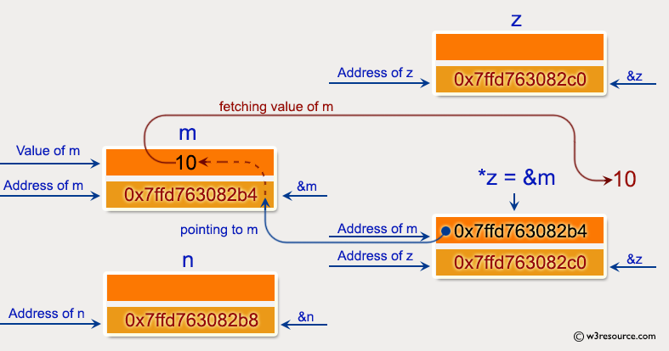

*Expected Output* :

Pointer : Show the basic declaration of pointer :

-------------------------------------------------------

Here is m=10, n and o are two integer variable and *z is an integer

z stores the address of m = 0x7ffd40630d44

*z stores the value of m = 10

&m is the address of m = 0x7ffd40630d44

&n stores the address of n = 0x7ffd40630d48

&o stores the address of o = 0x7ffd40630d4c

&z stores the address of z = 0x7ffd40630d50

**Question 2.** Write a program in C to demonstrate how to handle the pointers in the program.

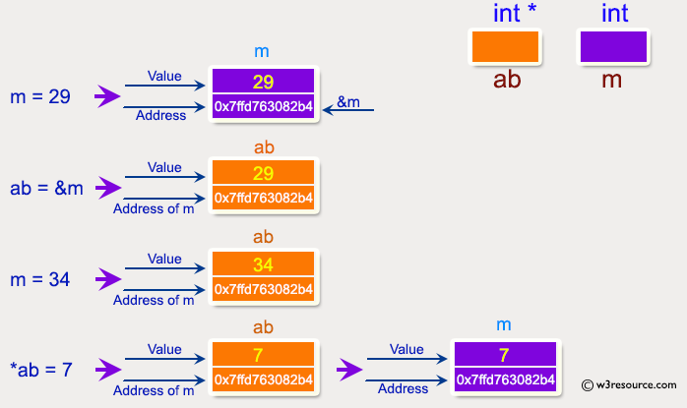

*Expected Output* :

Address of m : 0x7ffcc3ad291c

Value of m : 29

Now ab is assigned with the address of m.

Address of pointer ab : 0x7ffcc3ad291c

Content of pointer ab : 29

The value of m assigned to 34 now.

Address of pointer ab : 0x7ffcc3ad291c

Content of pointer ab : 34

The pointer variable ab is assigned with the value 7 now.

Address of m : 0x7ffcc3ad291c

Value of m : 7

**Question 3.** Write a program in C to add numbers using call by reference.

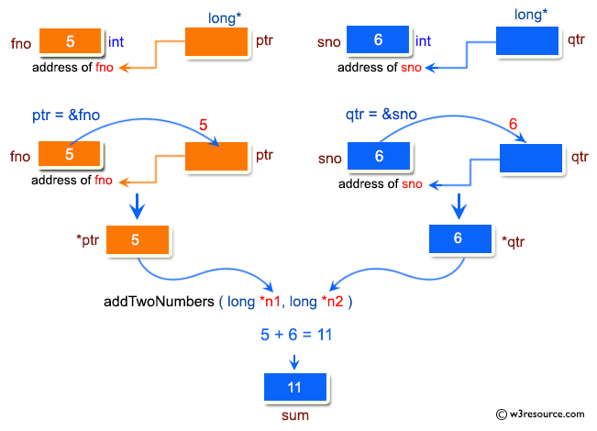

Test Data :  
Input the first number : 5  
Input the second number : 6  
*Expected Output* :

The sum of 5 and 6 is 11

**Question 4.** Write a program in C to compute the sum of all elements in an array using pointers

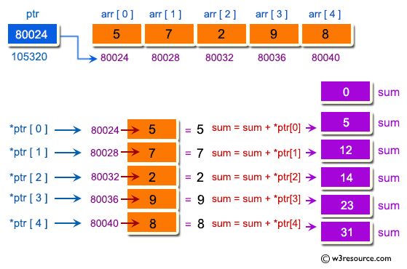

Test Data :  
Input the number of elements to store in the array (max 10) : 5  
Input 5 number of elements in the array :  
element - 1 : 2  
element - 2 : 3  
element - 3 : 4  
element - 4 : 5  
element - 5 : 6  
*Expected Output* :

The sum of array is : 20

